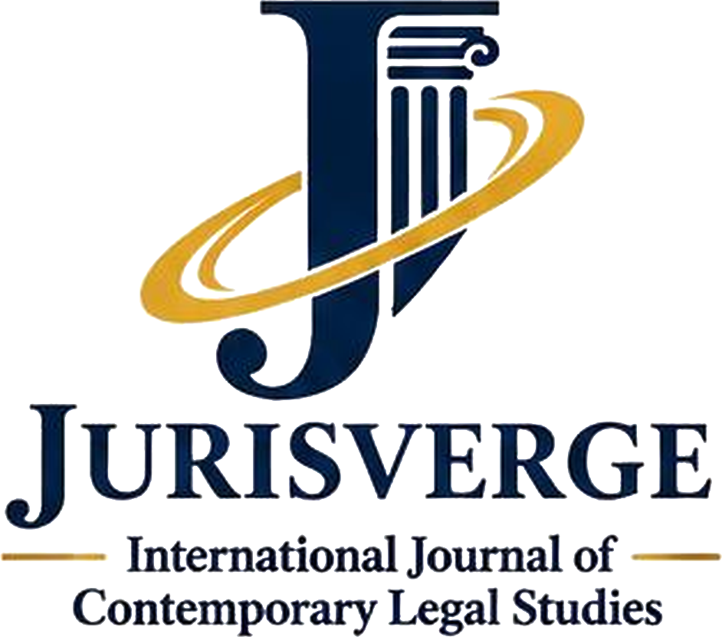
Copyright and Declaration Form
Title of manuscript
Author name(s)
Corresponding author
Designation and institution
Email

Declaration
I/We declare that:
- The work is original, and it has not been published before.
- It is not under review with any other journal.
- All sources are acknowledged, and the work does not infringe any third party’s rights.
- All named authors have contributed to the work and approved this submission.
- Any funding, conflict of interest and use of generative AI have been disclosed to the editors.

Licence
I/We keep the copyright in this work. I/We grant Jurisverge the right of first publication and agree that the work will be published as open access under a Creative Commons Attribution-NonCommercial-NoDerivatives 4.0 licence. Any later reuse will credit Jurisverge as the first publisher.

Signature
Name
Date

